|  |  |  |  |
| --- | --- | --- | --- |
|  | Bansilal Ramnath Agarwal Charitable Trust's  Vishwakarma Institute of Information Technology  Department of  Artificial Intelligence and Data Science | | |
| Name: Siddhesh Dilip Khairnar | | | |
| Class: SY-B tech | Division: B | | Roll No: 272028 |
| Semester: 3rd | | Academic Year:2022-2023 | |
| Subject Name & Code: ADUA21206 - Data Visualization | | | |
| Title of Assignment: Density maps | | | |
| Date of Performance: 12/11/2022 | | Date of Submission: 28/11/2022 | |

Aim:  Create visualization using any downloaded dataset for density map for any geospatial dataset.

Problem Statement: Download data set from Kaggle/Tableau/data world. Create visualization using any downloaded dataset for density map for any geospatial dataset.

Theory/Writeup:

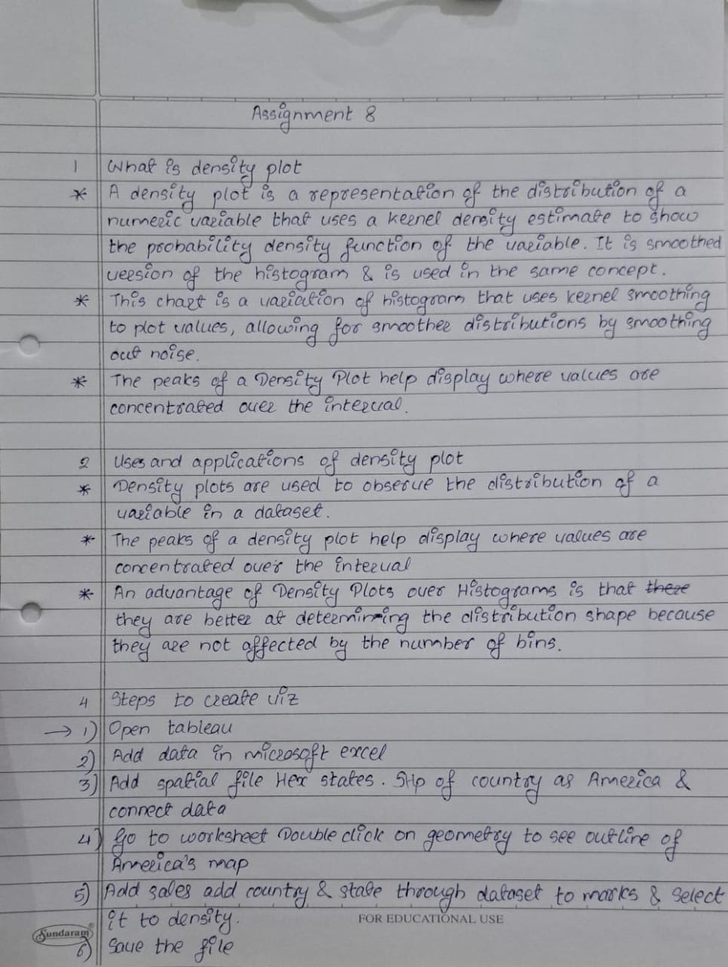

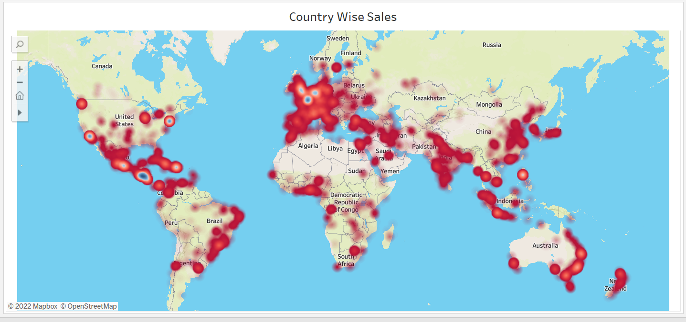 Visualization Snapshot:

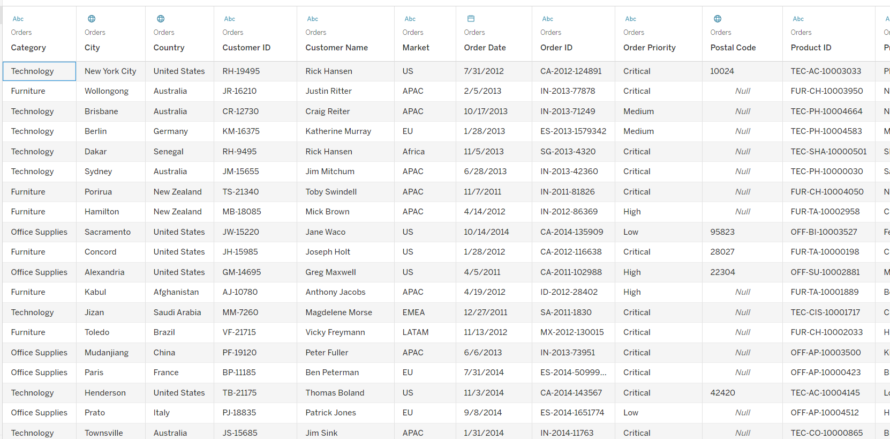

Tableau Public Profile Link:

<https://public.tableau.com/authoring/B_28_SiddheshKhairnar_DV_ASS8/Sheet7#2>